UNIVERSITY OF PETROLEUM AND ENERGY STUDIES


Student Name: Deepanshi Shukla
Sap ID: - 590021964
Batch: B10
Course: B. Tech (CSE)
SUBJECT: python Programming lab
Experiment: 6
Submitted to:
Kamakshi Rautela

Python Programming Laboratory
Experiment 6: Functions
1.Write a Python function to find the maximum and minimum numbers from a sequence of numbers. (Note: Do not use built-in functions.)
Code:
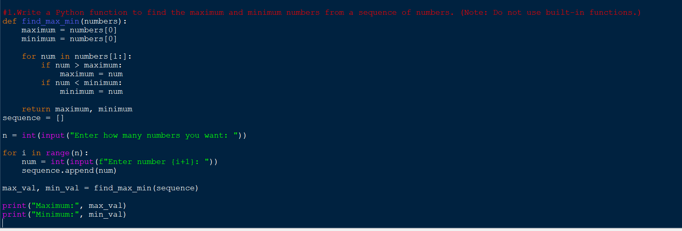
Output:
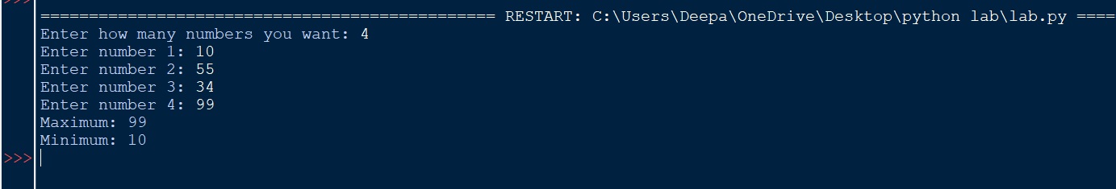
2. Write a Python function that takes a positive integer and returns the sum of the cube of all the positive integers smaller than the specified number.
Code:
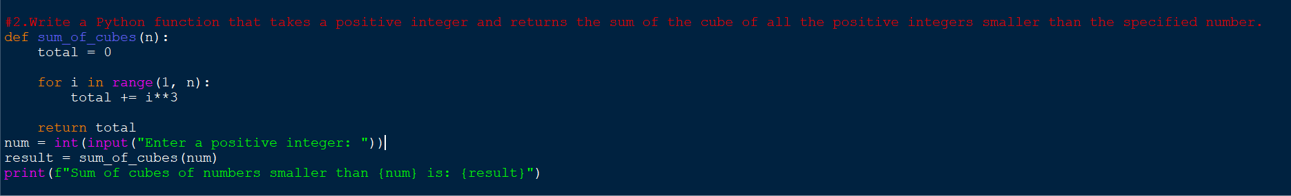
Output:
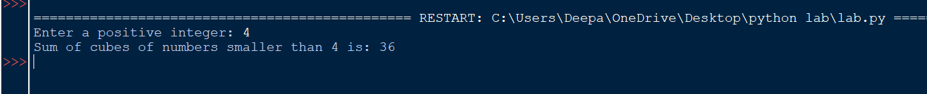
3. Write a Python function to print 1 to n using recursion. (Note: Do not use loop)
Code:
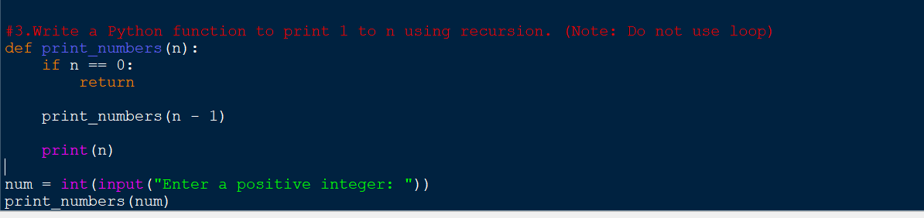
Output:
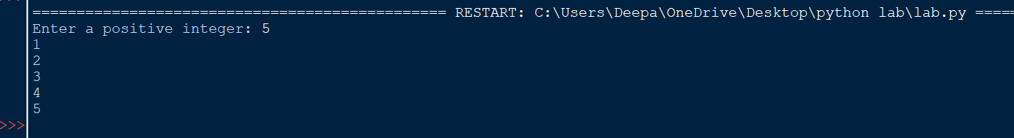
4. Write a recursive function to print Fibonacci series upto n terms.
Code: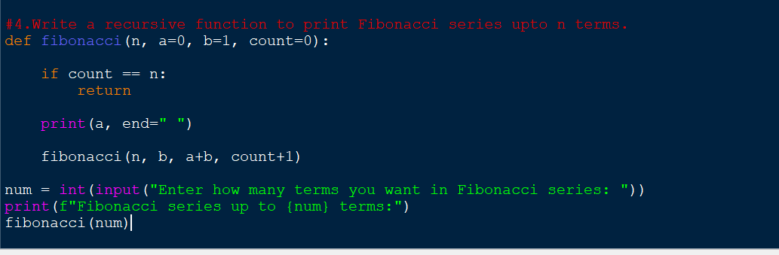
Output:
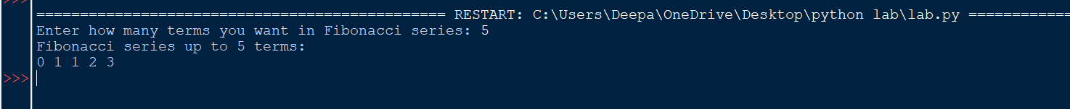
5.Write a lambda function to find volume of cone.
Code:
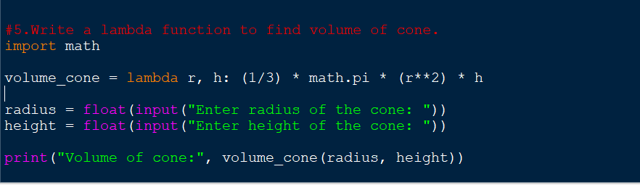
Output:
6. Write a lambda function which gives tuple of max and min from a list.
Sample input: [10, 6, 8, 90, 12, 56]
Sample output: (90,6)
Code: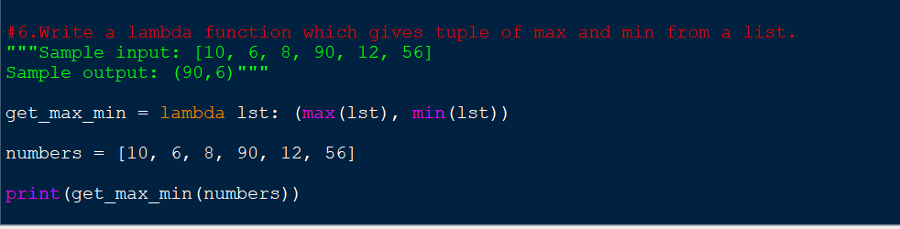
Output:
7. Write functions to explain mentioned concepts: Keyword argument
  - Default argument
  - Variable length argument
Code: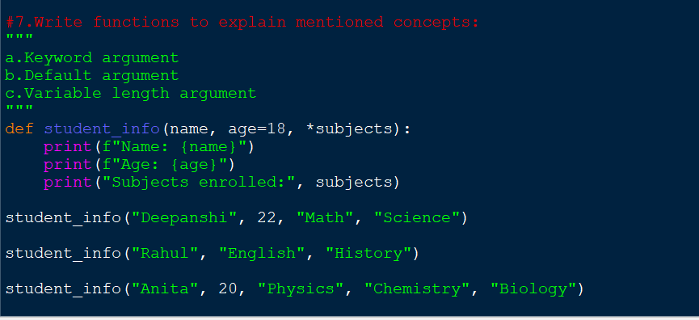
Output:
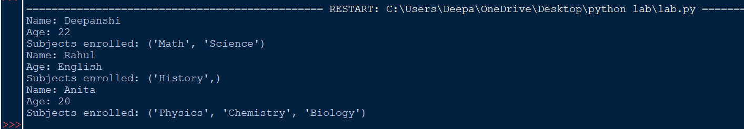
8.Write a program to check whether all the values in a dictionary are same or not using lambda function.

Code:
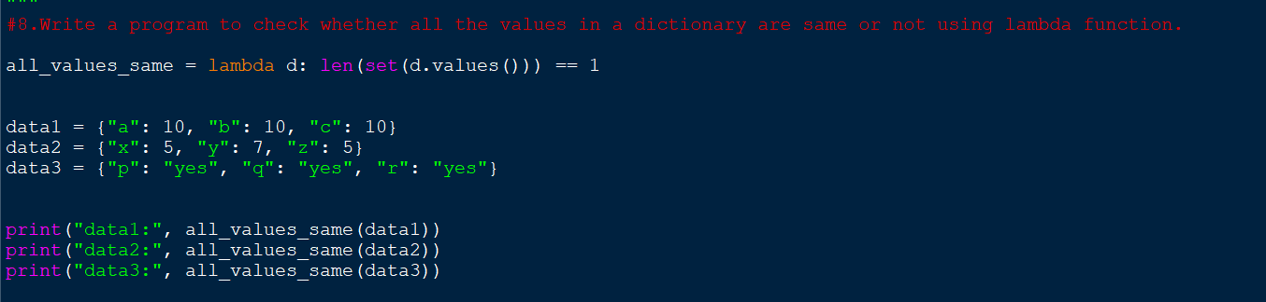
Output:
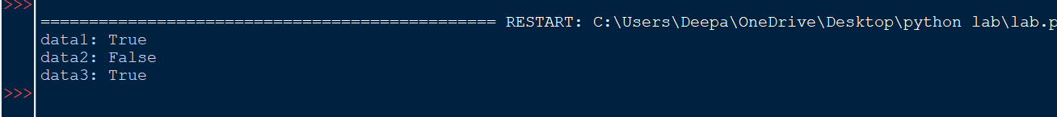
9.Write a program to create two lists and generate a dictionary with keys from list1 and values from list2.
Code:
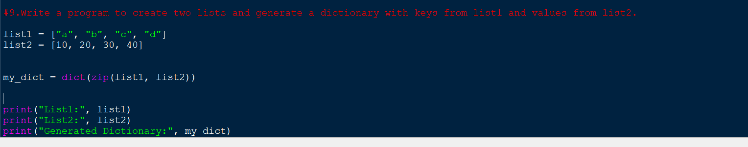
Output:

